**2.Three primary colors**

**1.Principle:**

The data protocol of the programmable RGB lamp adopts the single-line return-to-zero code communication mode. After the power-on reset, the DIN terminal accepts the data transmitted from the controller. The first 24 bits of data sent by the first pixel are extracted, the data latch is sent to the inside of the pixel. And the remaining data is shaped and amplified by the internal shaping processing circuit, then the output is forwarded to the next cascaded pixel by the DO port.

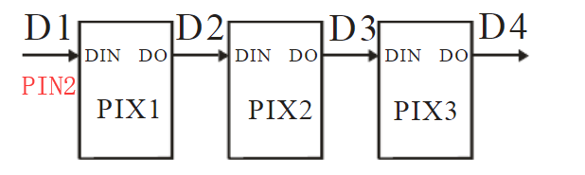

**Note:**

If the programmable RGB lamp is fully lit, the battery is not enough voltage, it will affect the effect,such as color saturation of RGB lamp is reduced or microphone not work normally.

It is recommended to use the USB data cable to plug in the RGB LED Circular expansion board interface. As shown in the figure below.

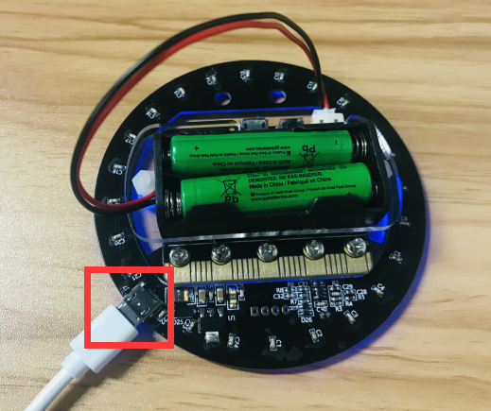

1. **Learning goals:**

In this lesson we will learn how to realize that the RGB LED Circular display red, green, blue three colors, switch one color every second by programming.

Note:This program can test the quality of the RGB LED Circular expansion board, this experiment need a lot of power. It is recommended to turn down the brightness of RGB lamp or use USB data cable.

1. ****Programming method:****

Online programming:

First,we need to connect the micro:bit to the computer by **USB data cable**, the computer will pop up a USB flash drive.Then, click on the URL in the USB flash drive: http://microbit.org/ to enter the edit process interface.

Offilne programming:

Open the offline programming software,download address of this software: **http://www.microbitgo.com/code.**

After creating a new project, you need to load the Neopixel library to program the programmable RGB lights. To load the library, click on 【Advanced】—【Extensions】 — click on 【Neopixel】, and you will see an extra column in the programming interface. As shown in the figure below.

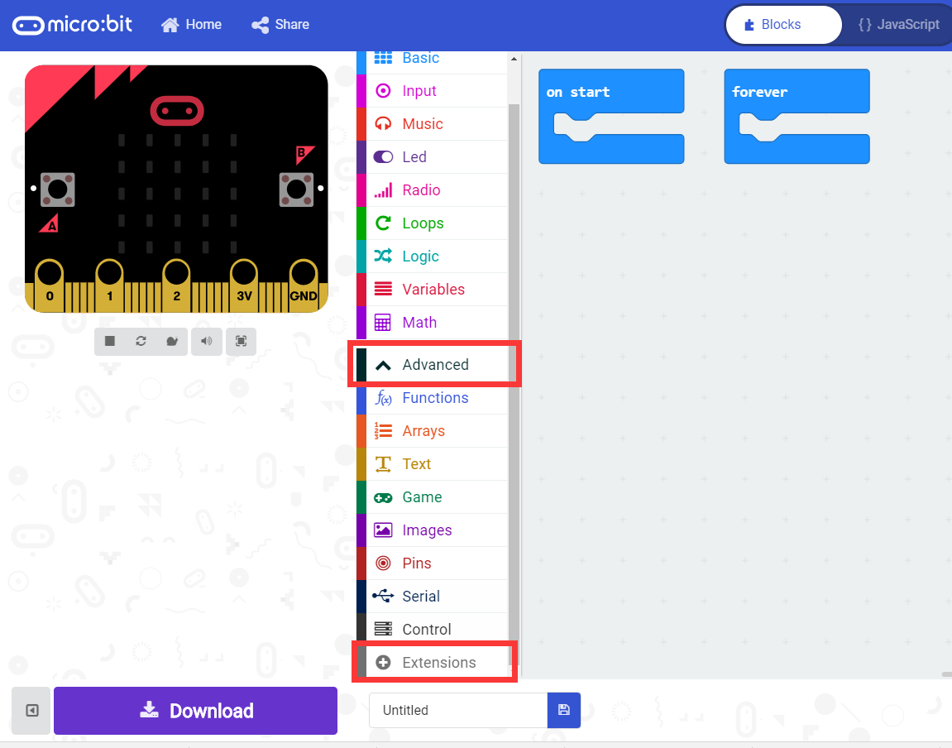

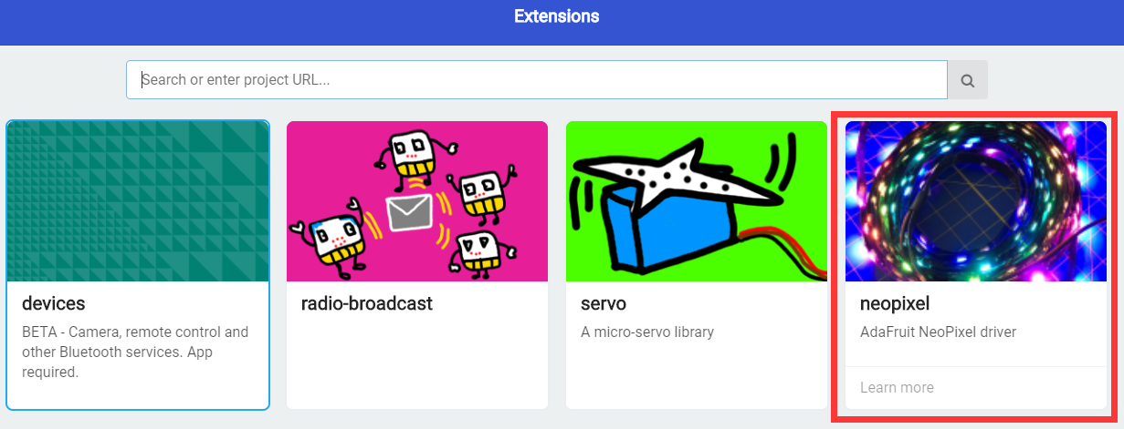

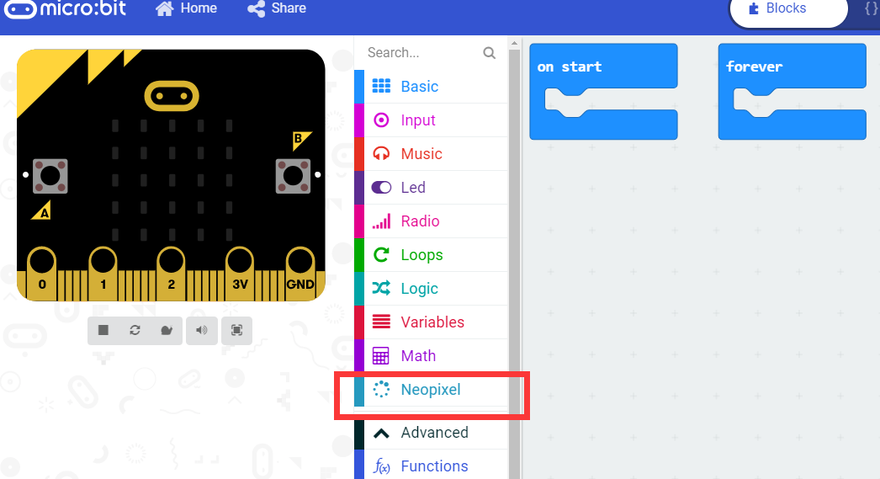

**General program diagram:**

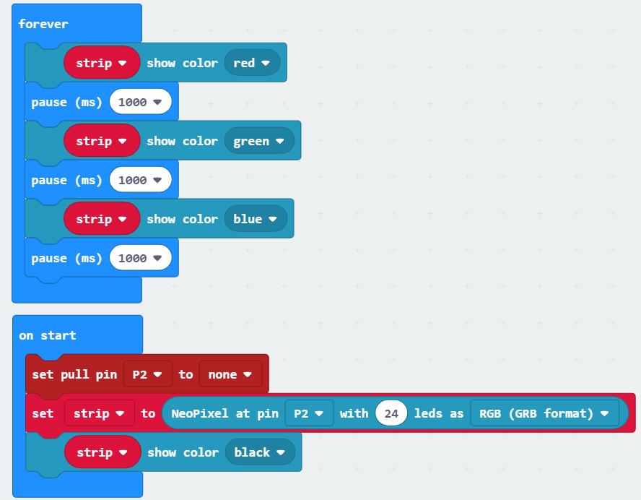

Our programmable RGB lamp is connected to the pin2 of micro:bit, so the pin2 is set to no pull-up/pull-down mode by default. Then use the following statement to create a new NeoPixel driver named Strip.

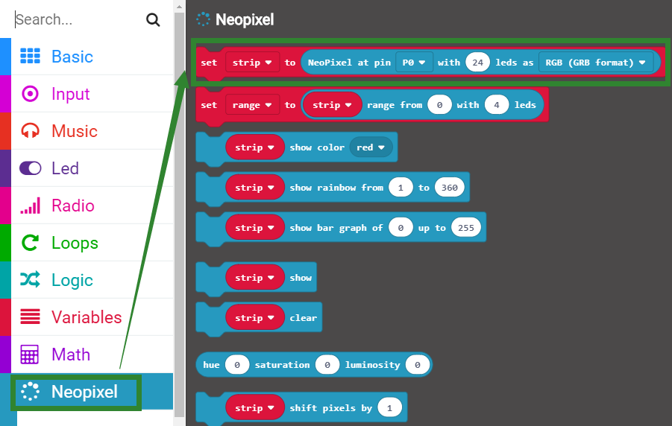

Then,we need to initialize the light ring to display no color, that is black.



**4.Download program**

We need to make sure that the micro:bit board is connected to the computer. Click the download in the lower left corner as shown below, and select the download path as micro:bit drive letter to download the program.

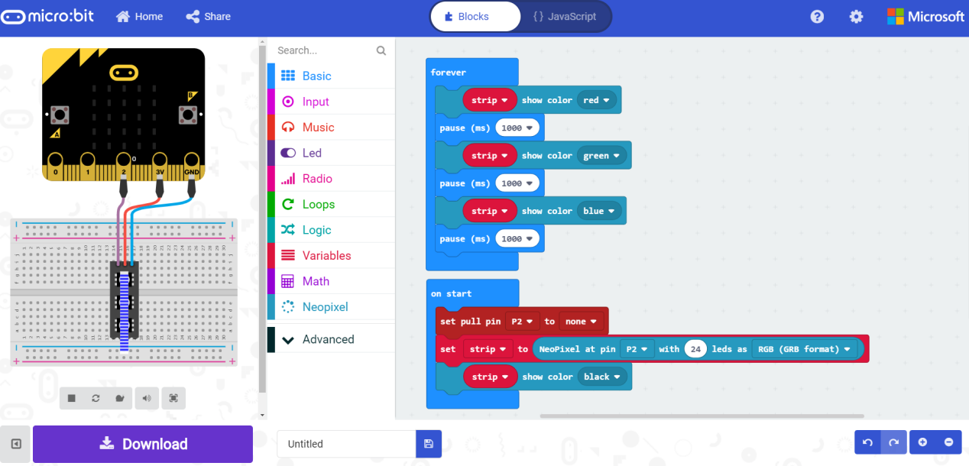

**5.Experimental phenomena**

After the program is successfully downloaded, you can see that the RGB LED Circular expansion board display three colors of red, green and blue, and switches one color every second. As shown in the figure below.

